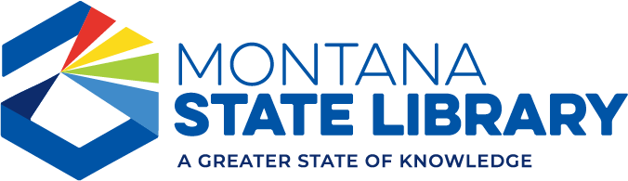

Foundation Directory Online – submitting a research request
Montana State Library staff can help you research grant makers who might be a good match for your project. The more details you can provide about the project, the better!
First, identify your needs:
- Who specifically are you serving? (Specific populations within your community? For example: children, seniors, veterans, etc?)
- Where are they? (Your city, your county, your reservation, your school district, etc?)
- What are you doing for them? (Educational programs? Workforce development?)
- What will success look like at the end of this grant-funded project? (As a result of this project, people in our community will...)
- How much money do you need? A ballpark estimate is fine.

Please contact Cara Orban (corban@mt.gov) with details about your grant project. Please let us know if you are looking for help compiling a list of grant makers, or preparing or reviewing a grant application, or both.

