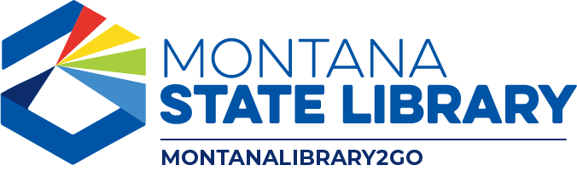

MontanaLibrary2Go Members Meeting
March 16, 2023

Agenda
FY2024 cost formula (ACTION)
FY2024 content budget (ACTION)
Selection Team sustainability and recruitment
By-laws discussion
OverDrive Advantage discussion
MontanaLibrary2Go dashboard review
OverDrive Extras review (Bobbi deMontigny)
Public comment
Adjourn business meeting

Optional post-meeting training: Accessing statistics and support via OverDrive Marketplace (0.5 CE, Collection Management)

