Printing your Certificate in ASPeN
To access your printable certificate in ASPeN follow these steps:
- Login
- Navigate to your ASPeN User page; once you are logged in on aspen.mt.gov, the link to your ASPeN User page is located in the Welcome box at the top of the right menu, at the bottom of that box, under the Logout/ePass Montana Home link. My user page looks like this (though your page may look a little different): 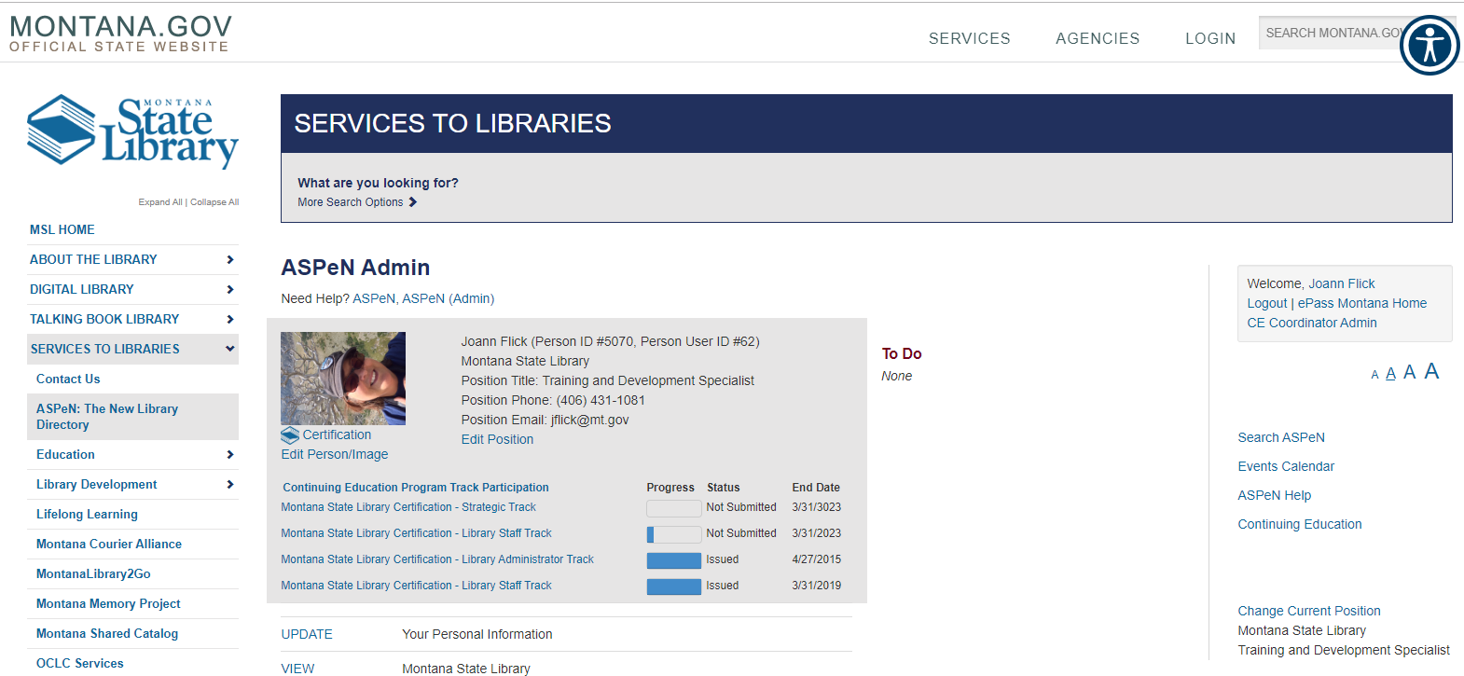
- Find your issued certificate(s) in the grey box Under your name phone and email information and click on the issued certificate that you want print (red arrow). Your most recent certificate issued will be at the bottom.
- The next page holds all the information about your issued certificate. The third item listed is “Continuing Education Program Track Participation Status” and will be marked “Issued (View Certificate).” Click on “View Certificate” to bring up your cert. It will look something like mine:
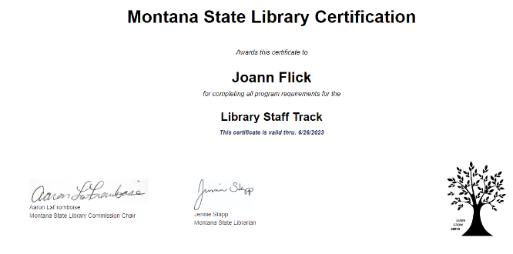

- You can then use the right click option to print your certificate or copy and paste the information into a MS Word document to print or save. This certificate lives forever in ASPeN and you can come back to it at any time.

