Claiming credits in ASPeN

To claim your credits toward Montana State Library Certification in ASPeN, you must first have a Certification Track participation identified in ASPeN. You may have more than one track simultaneously. See section #5 for how to select a track to begin. If you claim credits in ASPeN before you indicate a track, ASPeN will archive that information and post all eligible credits to your track once you have indicated one.

Credits earned at events posted to the ASPeN Events Calendar
Training that is directed at librarians and hosted in Montana either regionally or statewide is posted in the ASPeN Events calendar. Both live and recorded events are eligible for credit. Some examples of sponsors of this type of training are:
- Montana State Library
- Montana Library Association
- TRAILS consortium
- Library Federations
- MSL Vendors
- Libraries – system wide or regional
Three ways to claim your credits for events that are listed on the Events Calendar:
Login to ASPeN
- Register for an event, attend the event, check within a few days to be sure your credits are listed and you are marked “attended.” If you are not marked “attended,” contact the facilitator/trainer for that event and ask them to update your record in ASPeN.
- View a recording or attend an event that you did not pre-register for; login later to claim your credit by searching the events calendar and using the green “Add CE credit” button, check to be sure your credits are listed
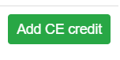
- Click on the “Continuing Education” menu option on the right menu from any page in ASPeN and select from the drop-down menu to claim your credits. On the next page, be sure to review your record and click “Save”
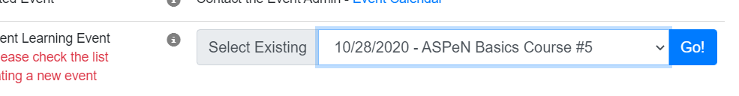

For events NOT listed on the ASPeN Events calendar
There are lots of training events that take place in Montana and across the globe that are excellent and qualified training for librarians. Examples include:
- Webinars outside of the Montana library community
- Online courses
- Out-of-state conferences
- Training events at your library only
To claim credit for these events, login to ASPeN, select the “Continuing Education” menu option on the right in the blue box and follow these steps:
- Check to be sure the training is not in the drop-down list
- Select the white button with red lettering: “Create New…”
- Complete all the fields marked with an asterisk and any other fields for which you have the information
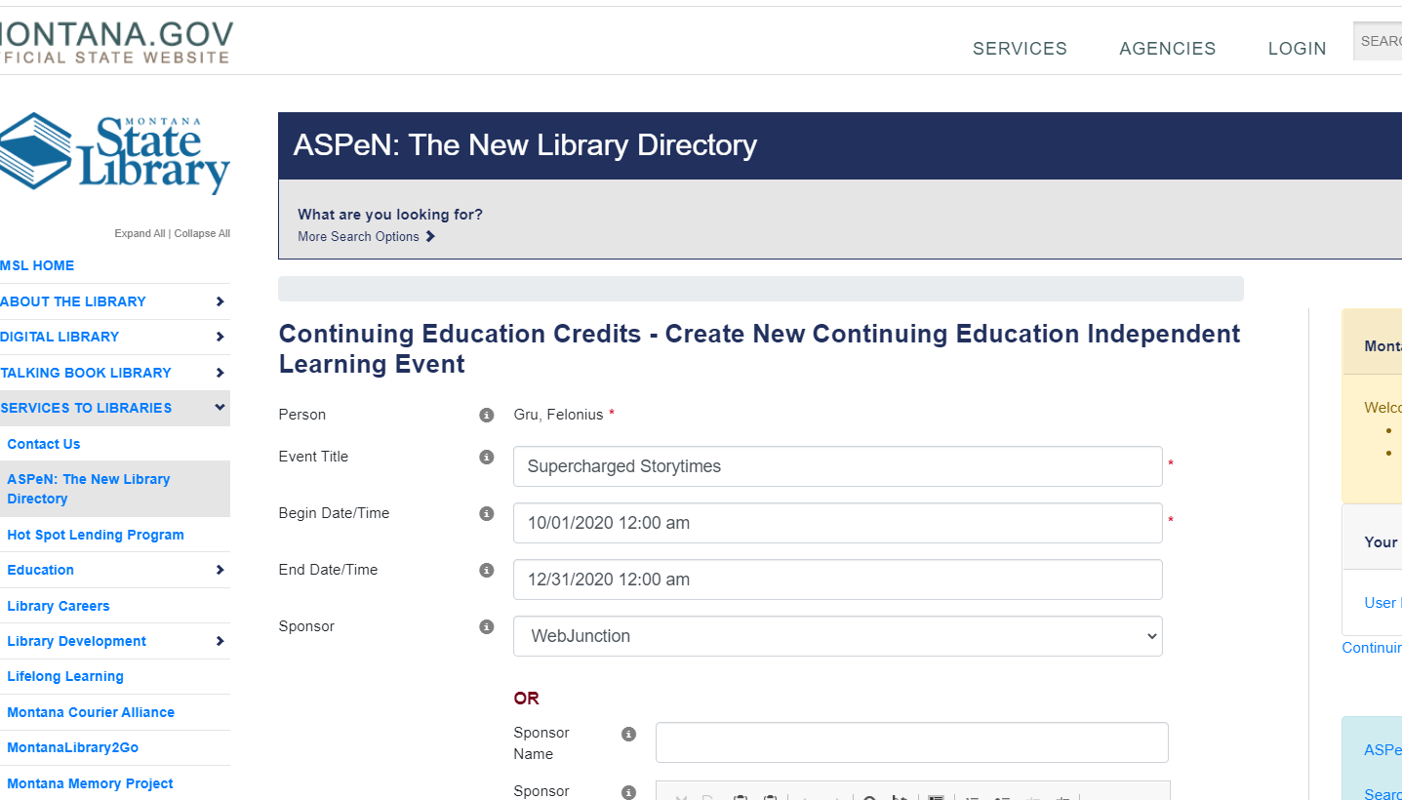
- Scroll down, select the correct CE category,
- Scroll to the bottom of this form and click “Save”

If there are errors in your entry, such as the wrong CE category, open a help ticket to correct any errors in your event record. Include the date and title of the event and the changes that need to be made.

