Submitting an Application for Montana State Library Certification
Consult the Montana State Library Certification Program Manual for information about the requirements that must be met to qualify for certification: https://libraries.msl.mt.gov/consulting/online_publications/certificationmanual
Most certifications are issued by earning CE credits to meet the minimum requirements of 60 total with a minimum of 10 credits in each of the four CE categories identified in the Montana State Library certification program. This tip sheet provides steps for applying for certification once the CE credits are attained. For those who have earned certification by attaining a recent masters degree in library science, contact the MT State Library CE Coordinator jflick@mt.gov

Steps to submit your application for certification:
- Login to ASPeN
- Navigate to your User Home by clicking on ASPeN Admin in the blue menu on the right
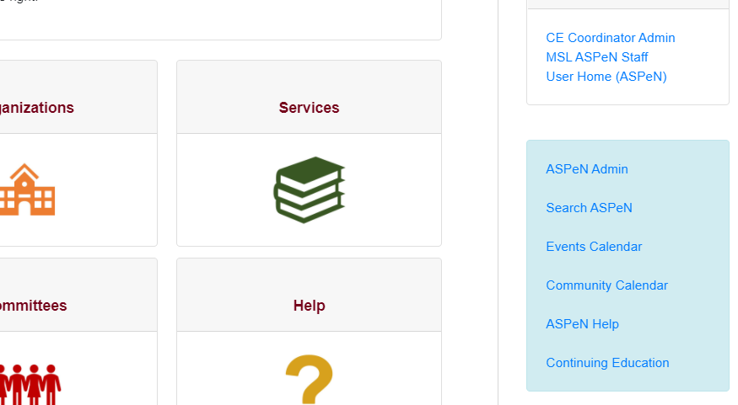

- Select the CE Track Participation from the grey box at the top of your User Home page

- Scroll to the bottom and review your credits to be sure there are no duplicates – open a help ticket to request duplicate credits be removed – provide the title and date of duplicate credits
- Select the person at your library that will verify your credits
- Select Submit

What happens next?
The CE Coordinator at the MT State Library reviews submitted applications at least once per month. If there are concerns or questions about your application, you will receive an email. Otherwise, an email is sent to the person that you identified in your application to verify your credits and copied to you at the email address listed in ASPeN. Credits are claimed on the honor system, but subject to verification by a superior when a participant applies for certification.
Participants should advise the person who will be asked to verify their credits of a pending email from the MT State Library and offer to provide evidence of your work or otherwise substantiate the credits you have claimed.
Once verification is received, the certificate is issued in ASPeN and a new track participation is created, ready to begin to collect new CE credits. Certificates may be viewed and printed in ASPeN.

To view certificate records and print certificates:
Login to ASPeN and click on the ASPeN Admin option in the right menu (blue box). Select an “issued” certificate to see the full record associated with that certificate. On the record page, an option to view/print certificate appears as hypertext. Click on that.

