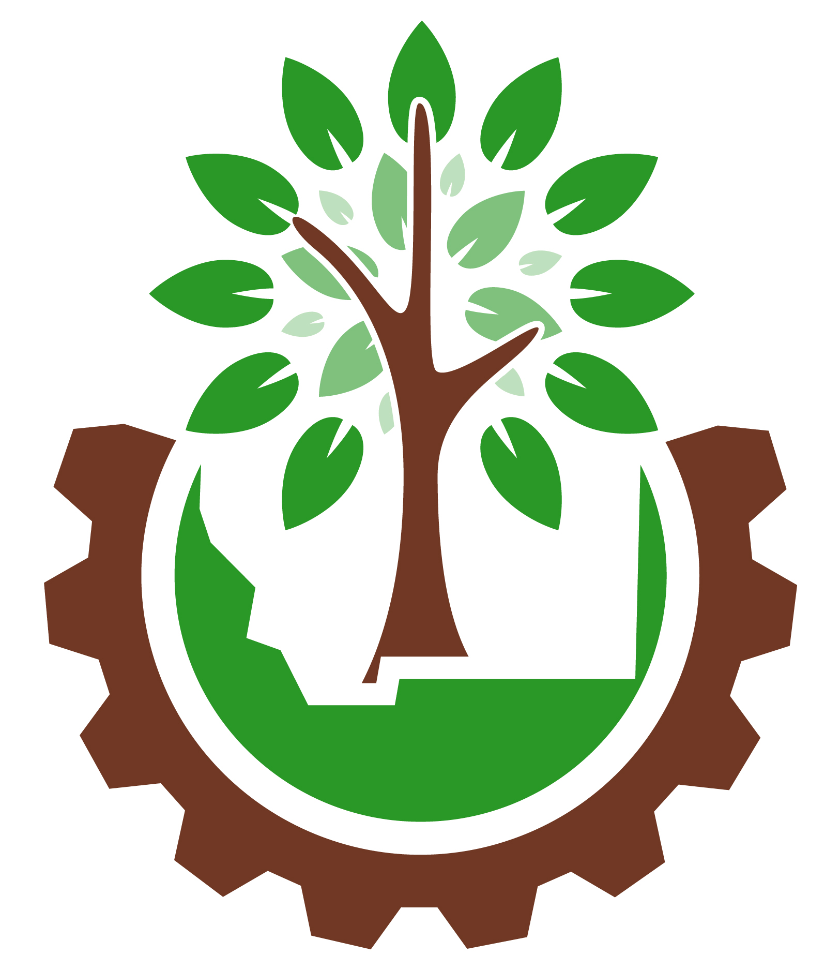
2020 VIRTUAL
Fall Workshops

November 17-18

Schedule-at-a-Glance

Tuesday, November 17th

Morning 8:30-11:30 am

Self-Care / Wellness

Serving the Undeserved: Implicit Bias*

Afternoon – 1-4 pm

Transforming Teen Services

Customer Service: De-escalation Techniques

Wednesday, November 18th

Morning 8:30-11:30 am

MSC Mobile

Serving the Undeserved: Programs & Services*

Afternoon – 1-4 pm

Community Engagement (11/4 pre-conference)

Personal Planning for Professional Development

* register once for both 11/17 & 11/18 sessions
Session Descriptions & Presenter Bios

Tuesday, November 17th MORNING

Self-care/Wellness
2020 has been a rough year. The daily and ongoing stress level is taking its toll. This session will focus on specific techniques to assess our own personal well-being and explore strategies to promote our spirit and support our bodies so that we are resilient and energetic.
The presenter for this session is Karin Peabody. Karin loves to remind people of their strength. She is a certified StrengthsFinder Communicator, and is passionate about helping leaders own and model a Healthy Work Culture (whether they are in a management position or not!). Her workshops cover topics related to Emotional Intelligence, Healthy Boundaries, and Self-Awareness - the "soft skills" that make our workplaces and families strong, resilient, and hopeful. Find out more at DynamicTeaming.com.

This session will not be recorded.

CE category: library administration

Link to register: https://mslservices.mt.gov/ASPeN/Events/Event_Detail?Event_ID=18557

Serving the Underserved: Implicit Bias
Montana’s schools have broken new ground with a curriculum called Indian Education for All (IEFA) that explores the culture and history of our Native American nations. In this, the first of two sessions, we will pull from the work already done in Montana schools to explore how libraries can better serve Native Americans in our communities, and to help promote and preserve the rich culture of our state. First, we’ll explore the concept of implicit bias and how our personal heritage can be a hidden barrier to reaching out and serving our whole communities. The follow-up session in this two-part class will be held at the same time on 11/18.
The presenters, Miranda Murray and Jordann Lankford, are Indian Education for All instructional coaches for the Great Falls Public School District. They are the lead facilitators for Bright Trail Education, an educational consulting company. Murray and Lankford have presented their work throughout the United States and have been recognized for their roles in Indian Education for All and dropout prevention.

Portions of this session will be recorded and posted to the MSL Vimeo Channel.

CE category: library services to the public

BY REGISTERING TO ATTEND THIS SESSION, YOU WILL AUTOMATICALLY BE REGISTERED TO ATTEND THE SESSION ON 11/18 8:30-11:30 am ON PROGRAMS & SERVICES.

Registration link for this session: https://mslservices.mt.gov/ASPeN/Events/Event_Detail.aspx?Event_ID=18630
Tuesday, November 17th AFTERNOON

Transforming Teen Services: Using Connected Learning in Your Library Work
Come and learn about how to use Connected Learning, a way of teaching that supports personal interests through a strong support network of peers, mentors, and caring adults, in your library to better facilitate opportunities for Computer Science and Computational Thinking for the teens in your community. Led by Heather Dickerson and Cody Allen, this program is part of YASLA’s Transforming Teen Services grant.
Heather Dickerson is the Teen Services Librarian at Lewis & Clark Library in Helena. A raucous Harry Potter program is her favorite thing to plan. When she is not at the library, she’s outside with her family.
Cody Allen is the Young Adult & TECH Lab Librarian at Billings Public Library. He spends most of his time at the library running a digital learning lab for teens that focuses on STEAM programming built around the principles of HOMAGO and Connected Learning. In his free time, he enjoys tabletop games, hiking and fly fishing.

Portions of this session will be recorded and posted to the MSL Vimeo Channel.

CE category: library services to the public

Link to register: https://mslservices.mt.gov/ASPeN/Events/Event_Detail?Event_ID=18564

Customer Service: De-Escalation Techniques

When tensions are high and both staff and patrons are encountering new rules and restrictions, there are ample opportunities for uncomfortable interactions in the library. The wide range of very strong opinions on how and what COVID related changes are in place certainly exacerbate the conditions that library staff are working under at this difficult time. This session will help librarians understand how conversations go awry and to learn practical ways to immediately address a tough patron conversation while keeping the library and library staff safe. The initial presentation will be recorded and posted to the MSL Vimeo Channel and available until 12/31/20, but the practice sessions utilizing role-plays will be live only, so the attendees can fully experience the value of the role-play model without being recorded. Handout resources will include the role play scenarios for staff to use with the peers back at the library, so this session can be utilized as a “train-the-trainer” model so participants can offer the training to their peers.
Andrew Sanderbeck is the presenter of this session. Andrew’s company, People Connect Institute was the sponsor of the popular webinar series offered to Montana librarians last Spring and early summer. He is an expert trainer in understanding social interactions and using effective interventions to promote safety and clarity. Andrew has years of experience training the hospitality industry and with libraries, and has taught classes for Johnson and Wales University on maintaining a collaborative business culture.

A portion of this session will be recorded and posted through the end of 2020 on the MSL Vimeo Channel.

CE category: library services to the public

Registration link for this session: https://mslservices.mt.gov/ASPeN/Events/Event_Detail.aspx?Event_ID=18644

Wednesday, November 18th MORNING

Serving the Underserved: Programs & Services

This second session in the series shifts the focus to examine the programs and services at your library to address the needs of underserved audiences in your community. Drawing on their experience in Montana helping teachers to implement the Indian Education for All program in schools, the presenters will share best practices for reviewing the library’s work and looking for ways to improve so that new audiences are better served and feel welcome at the library.
Miranda Murray and Jordann Lankford co-present both sessions.
REGISTER FOR THE 11/17 SESSION AND YOU WILL AUTOMATICALLY BE ENROLLED IN THIS SESSION.

Portions of this session will be recorded and posted to the MSL Vimeo Channel.

CE category: library services to the public

Register for the first session in this 2-part series here and be automatically registered to attend 11/18 – must attend both sessions: https://mslservices.mt.gov/ASPeN/Events/Event_Detail.aspx?Event_ID=18630

Using the Montana Shared Catalog App & MobileStaff (previously MobileCirc)

Experience BLUEcloud Mobile, the MSC’s new app that patrons can use to manage their accounts, search your catalog and MontanaLibrary2Go, and so much more! Attendees will learn how to:
- Download the app onto a smartphone and log in.
- Manage your account, including checkouts, holds, etc.
- Link other library accounts in the app.
- Explore your print and digital collections, as well as other Montana resources, all in one place!
- View library hours, location, and contact info right when it’s needed.
Refresh your memory on how to use MobileStaff (previously named MobileCirc) to:
- Perform basic circulation tasks, including viewing an onshelf items list of holds.
- Inventory your collection.
- Conduct outreach.
This workshop is intended for staff whose libraries are members of the Montana Shared Catalog, but all are welcome!
Presented by MSC staff, Keiley McGregor and Rebekah Kamp. Keiley McGregor, Montana Shared Catalog Trainer, specializes in demystifying the MSC’s integrated library system. Online tutorials are her weapon of choice (because who remembers how to do something perfectly the first time?!). She earned her MLIS from Simmons College in 2013 and recently completed a MicroMasters in Instructional Design and Technology through edX. She believes that successful learning almost always comes down to mistakes, humor, and small, consistent steps forward.
Rebekah Kamp, Montana Shared Catalog Systems Administrator, specializes in analytics and public access and discovery products. Prior to joining the Montana State Library in 2017, she worked as a librarian in a variety of roles, including cataloging, technology, and youth services. She earned her MLIS from the University of Washington in 2011. Outside of the office, Rebekah volunteers with the Girl Scouts and explores the world near and far with her husband and three children.

Portions of this session will be recorded and posted to the MSL Vimeo Channel.

CE category: collection management and technical services

Registration link for this session: https://mslservices.mt.gov/ASPeN/Events/Event_Detail?Event_ID=18558

Wednesday, November 18th AFTERNOON

1-4 pm

Community Engagement for Small Public Libraries

Recent events have turned our world upside down. As we rebuild, public libraries will play an integral role in creating sustainable, resilient communities. To do so requires a commitment to work with our communities to reach their aspirations, and understand our role in a complex socio-ecosystem. Small, rural libraries are perfectly positioned to lead the way in doing this work.
Erica Freudenberger will present two interactive, virtual training sessions to introduce community engagement practices to Montana’s libraries. REGISTER FOR THE 11/4 TRAINING TO BE ENROLLED AUTOMATICALLY IN THE 11/18 SESSION.
By the end of this two-part training, participants will be able to:
- Create sustainable, resilient libraries by utilizing a community engagement framework for libraries
- Identify, collect, and organize local resources to help them achieve their community’s aspiration
- Articulate what they’ve learned with others, including their Board, staff, and community stakeholders
Erica Freudenberger has been creating community-led change for decades. Currently the Outreach & Engagement Consultant at the Southern Adirondack Library System, she formerly led Red Hook Public Library, a finalist for Library Journal’s “Best Small Library Award.” After taking part in the American Library Association’s Libraries Transforming Communities initiative in 2014, she was invited to work on the Re-envisioning Public Libraries pilot with the Aspen Institute. Named a 2016 Library Journal Mover & Shaker in the category of Community Builder, she garnered the Public Library Association’s Upstart Innovation Award in 2019. She founded Thriving Libraries, LLC., to help libraries create sustainable, resilient communities.

Portions of this session will be recorded and posted to the MSL Vimeo Channel.

CE category: library services to the public

Registration Link for this session:

Personal Planning for Professional Development

1-3 pm

Training is important in any job but especially in libraries because libraries are always moving on the cutting edge of transformations. Libraries react endlessly to technology changes, social needs, community interests, political climates and (as we have recently discovered) local, national and global crises. As the Montana State Library launches the new Strategic Track to support veteran library staff, this session will help library directors and those who are looking to advance their careers in librarianship to understand the direct relationship between the training you choose, the work you do, and the success of your library’s programs and services. The new Strategic Track for MT State Library Certification supports a model for planning training that is customized to the needs of the learner and the library where they work.
Presenter, Elizabeth Woodard, is the Training and Technology Coordinator for the Norfolk Public Library in Virginia. Elizabeth has been a business owner and worked in the retail industry as well as at both school and public libraries. Responsible for the training or teaching of others and She has come to believe that Success Happens when yOUr Learning is Designed for it. SHOULD!

Portions of this session will be recorded and posted to the MSL Vimeo Channel.

CE category: library administration

Registration link for this session: https://mslservices.mt.gov/ASPeN/Events/Event_Detail.aspx?Event_ID=18646

