ASPeN Basics #3:
Updating Your Organization’s Information
- Navigate to ASPeN: aspen.mt.gov
- Log in with your ePass Montana credentials by clicking the LOGIN button on the right-hand menu (or Create an account if you don’t have one - fill out the registration form as you would for any site). Yes, there will be several clicks required.

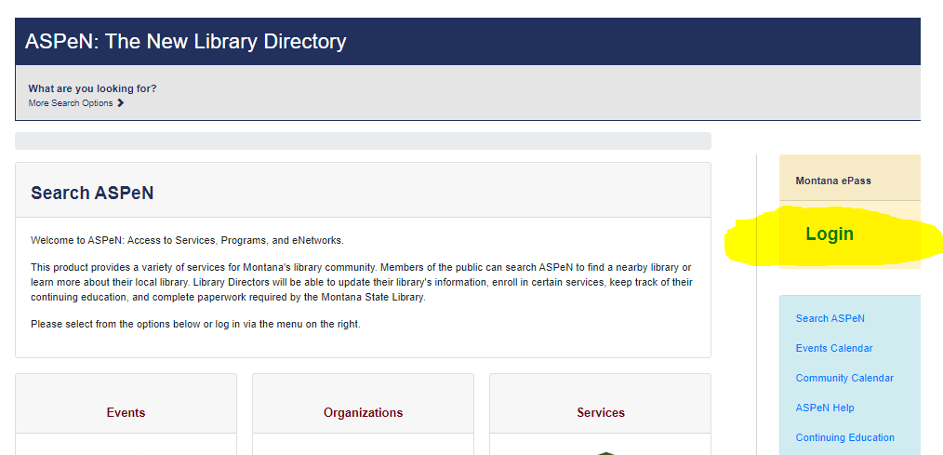
- Once at the ASPeN main page select ASPen Admin on the right-hand menu.
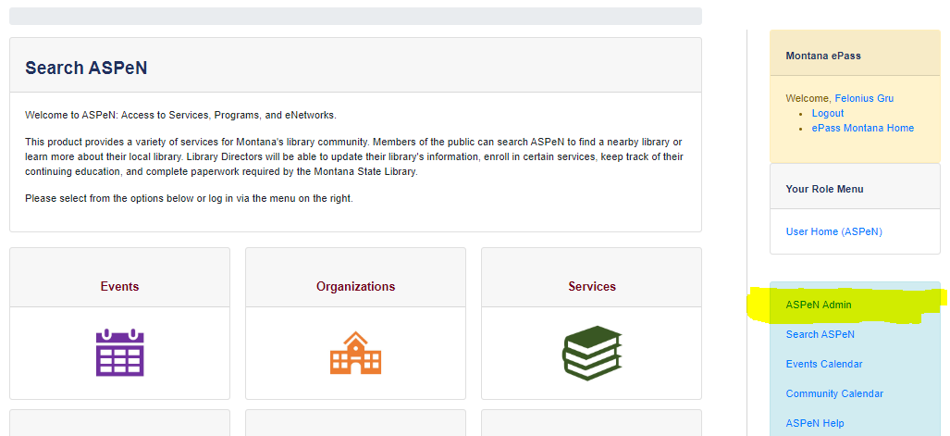
- This brings up your personal ASPeN home page (the large gray box).
- You will see the following options under the large gray box:
  - Update Your Personal Information
  - Update [YOUR ORGANIZATION NAME]
  - Update [YOUR ORGANIZATION NAME ADDITIONAL INFORMATION]
  - View [YOUR ORGANIZATION NAME]
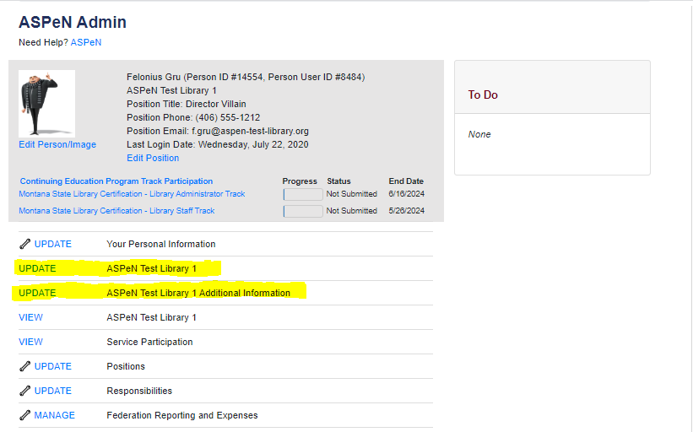
- Click on “Update [YOUR ORGANIZATION NAME]. You will be taken to a page where you can edit all of your organization’s information. You can change the name, the phone number and contact information, the website, hours, etc. Edit and make whatever changes you want to.
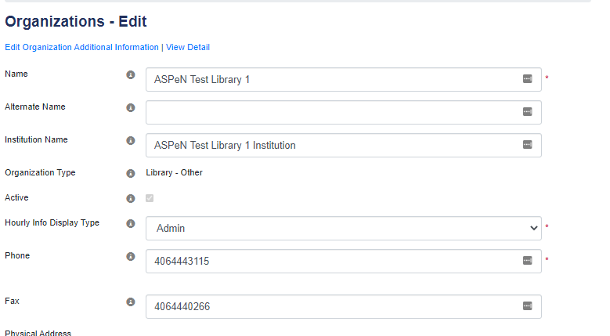
- Scroll down to see the SAVE button. Once the page refreshes a confirmation notification appears.
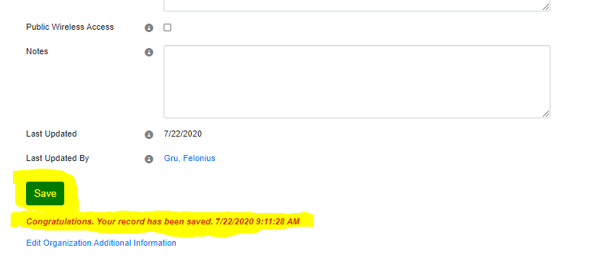
- You can also edit your organization’s additional information, either by clicking on that option in your ASPeN Admin page, or clicking on “Edit Organization Additional Information” under the SAVE button from Step 7.
