How to Record Federation Expenses in ASPeN

These instructions are for libraries who receive money from one of the library federations. The instructions explain recording how you spent the money received. If you have any problems with the system, please either let Tracy Cook know at TCook2@mt.gov or click ASPeN Help and submit a ticket for assistance.

Confirming Your Award
- This needs to be completed the first time you login to record your expenses.
- Log into ASPeN
- Click on ASPeN Admin
- Click on Manage Federation Reporting and Expenses located under the grey box in the center of the page.
- Select your library from the drop-down menu
- Click go

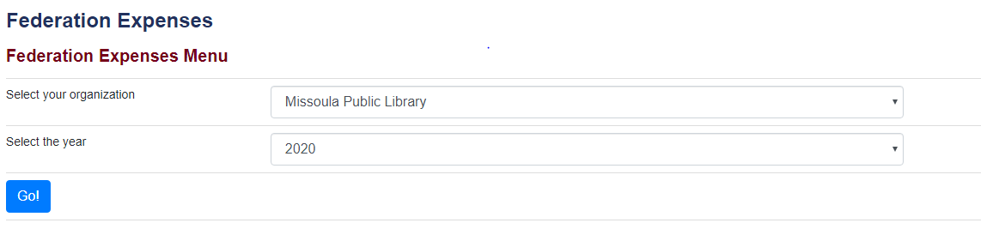
- Click Confirm/View Award
- Review the award to see if the total amount listed matches what you received.
- Click “Confirm Award”
- Click “Ok” after reading the grant agreement message that appears
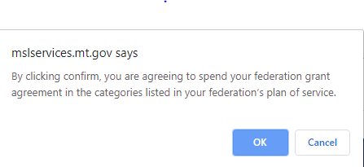
- Click “Ok” after receiving the success message
- Click on “Federation Expenses” on the right hand-side of the screen. It appears above the blue box to return to the main menu.

Recording How You Spent Your Federation Funds

- Log into ASPeN
- Click on ASPeN Admin
- Click on Federation Expenses
- Select your library from the drop-down menu
- Click go
- Select Add Expenses
- Complete the form that appears. TIP: Type in the date of the expense, and the calendar widget will automatically go to that date. You can click on the date to finish the process.
- The items with a red asterisk are required.
- Here is a copy of a completed form
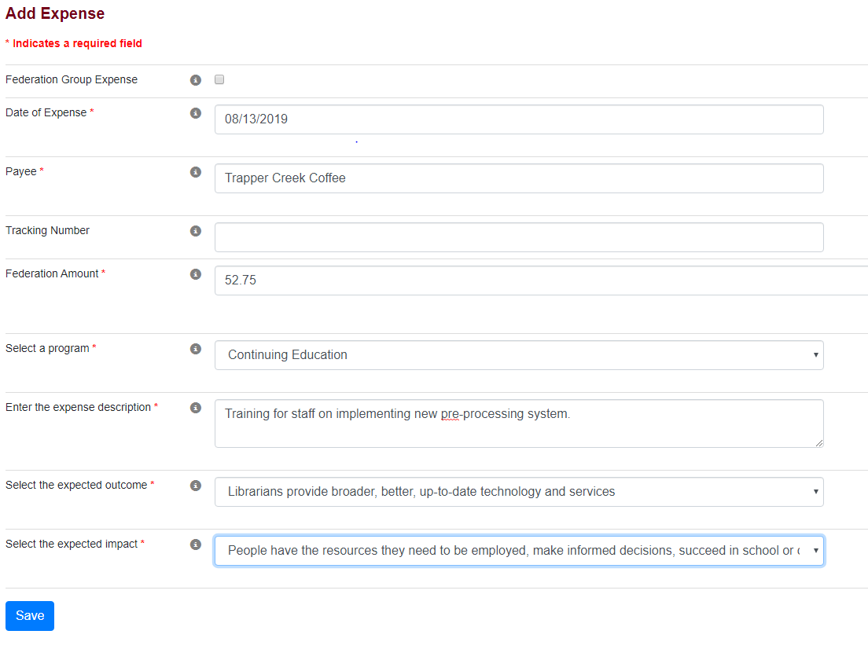
- Click “Save” and then “Ok” to finish the process

